**Name: Sruthy Chandran**

**Roll No:43**

**Batch:MCA**

**Date:31/03/22**

**NETWORKING & SYSTEM ADMINISTRATION LAB**

**Experiment No.: 4**

**Aim**

Familiarization of basic linux commands

**Procedure:**

1. cat -n

print conents with number

**syntax:**

$cat -n b1.txt

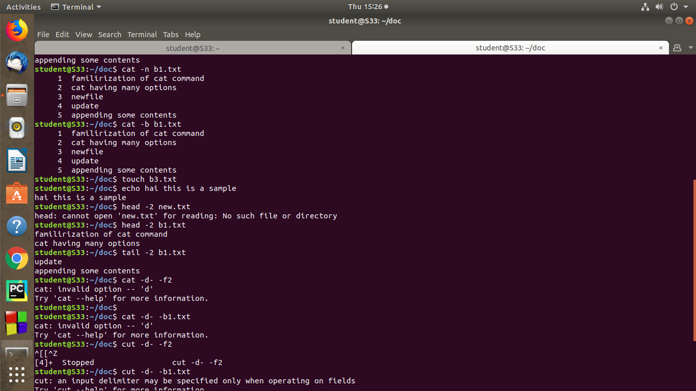**output:**

2. cat -b - remove the empty lines and redirect the line number.

**syntax:**

$cat -b file.txt

**output:**

3.  **touch**

syntax:The touch command allows you to

$touch b3.txt

**output:**

5. echo

syntax:

$echo contents

**output:**

6.**head**

syntax:

$head -2 new.txt

**output:**



7. Tail

**syntax:**

$tail b1.txt

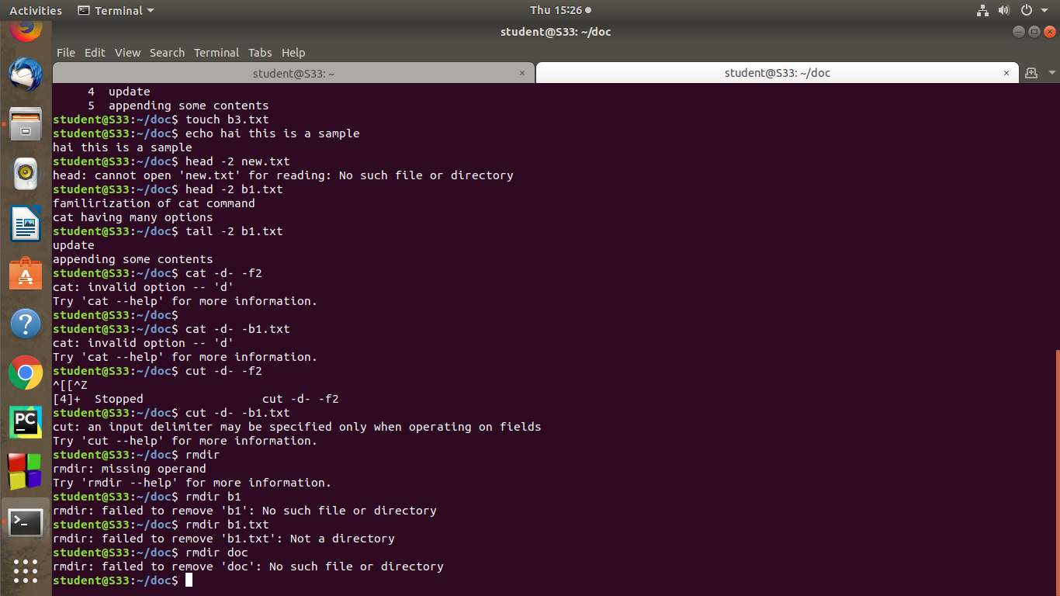

8. **cut -d** - -d option is used then it consider space as a field separator or delimiter.

**syntax:**$ cut -d ‘ ‘ f1 samples

**output:**

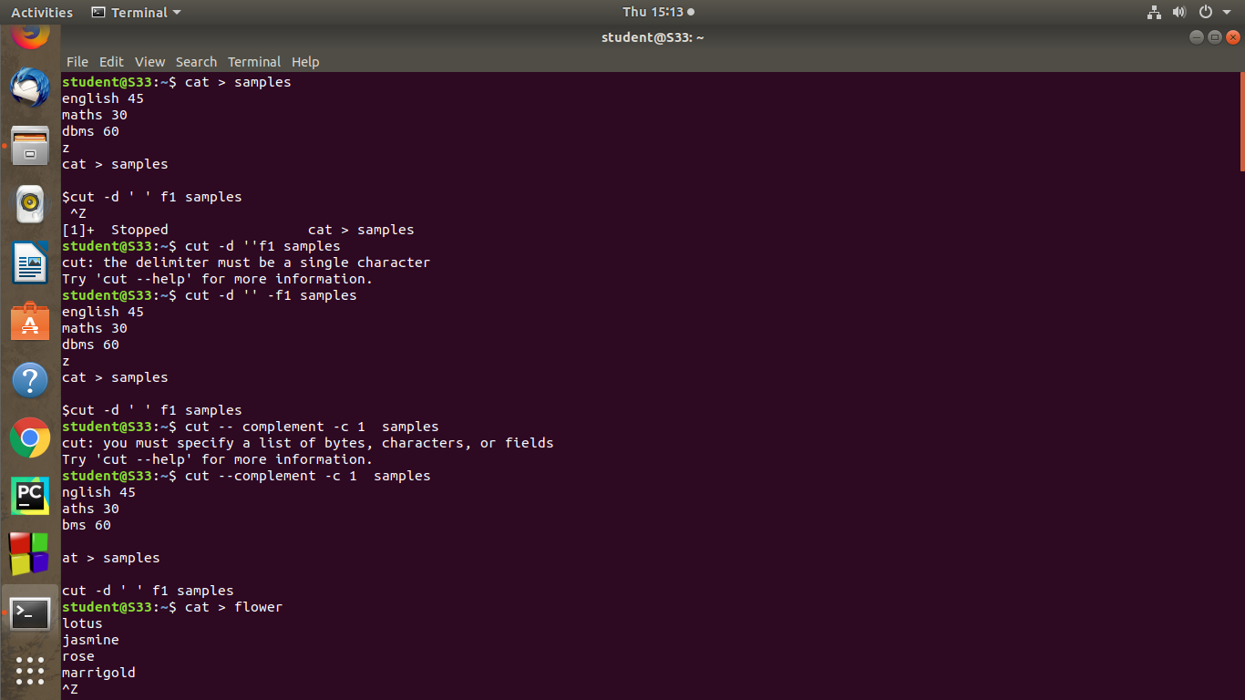9) **paste -** It is used to join files horizontally (parallel merging) by outputting lines consisting of lines from each file specified, separated by tab as delimiter, to the standard output.

**syntax:**

$paste file1

**output:**

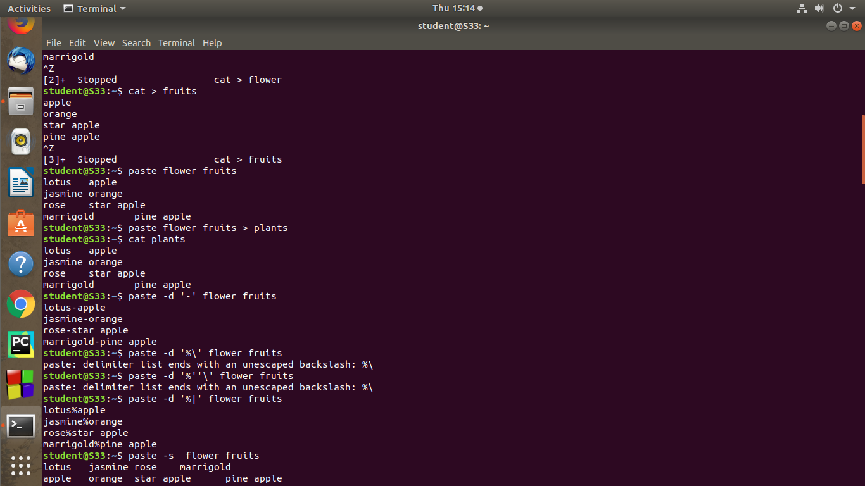

**10. more -** more commands is used to view the text files in the command prompt, displaying one screen at a time in case the file is large. The more command also allows the user do scroll up and down through the page.

**syntax:**

$more file1

**output:**

